# **KOREAN DRAMA**

# INTRODUCTION:

OVERVIEW:

The popularity of Korean dramas (Korean dramas) has soared globally, and in 2023, the market is ﬂooded with numerous productions. Here we have leverage the power of Cognos an analytics platform, to analyze the top 100 Korean dramas of 2023 and generate actionable insights that can guide decision-making and strategy formulation for stakeholders in the Korean drama industry.

PURPOSE:

Strategic Decision-Making and Market Positioning: Intelligent analytics on the Top 100 Korean drama 2023 dateset empowers production companies, platforms, and advertisers to make data-driven decisions.

# LITERATURE SURVEY

Existing problem:

The existing problem of this analysis is the normal analysis approach from the given data set of the Korean dramas

Proposed solution:

From the given Korean dramas data the analysis is done using IBM cognos, python,ﬂask, were Django visualization,bar graphs, bar charts,etc were also used in it , in which it makes the analysis to the next level and also the analysis we have done helps in the greater impact in the business domain. guide content selection, investment allocation, and targeted advertising, enhancing competitiveness and establishing a strong market position in the dynamic Korean drama industry.

FLOWCHART:

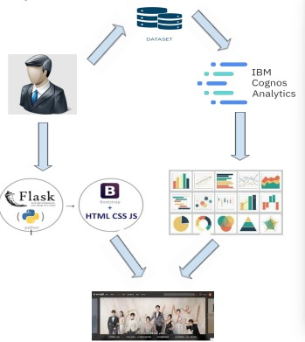

EXPERIMENTAL INVESTIGATIONS:

The analytics performed on the Top 100 Korean Drama 2023 Dataset can provide insights into viewer preferences, enabling production companies to create content that resonates with diverse audiences. By understanding viewers' interests and cultural inﬂuences, Korean Dramas can foster social connections, promote cultural exchange, and contribute to a shared viewing experience.

# RESULT:

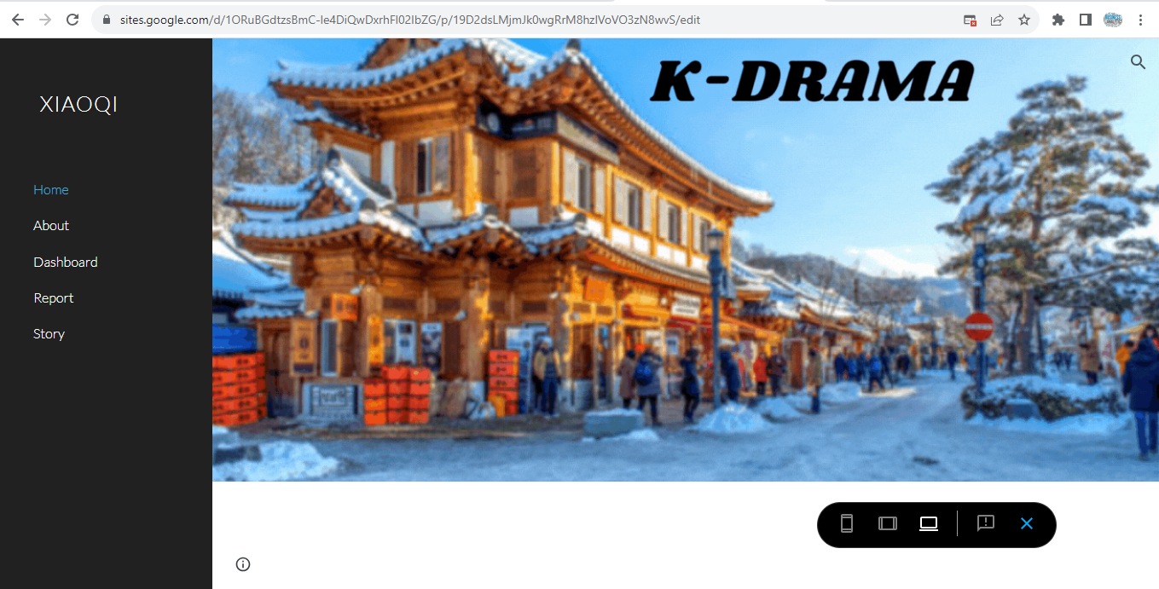

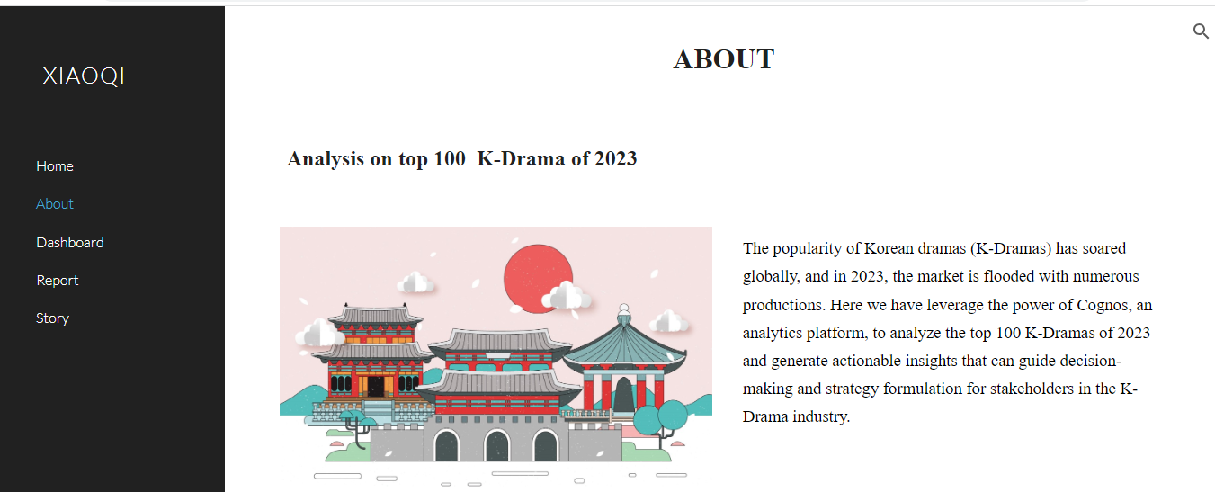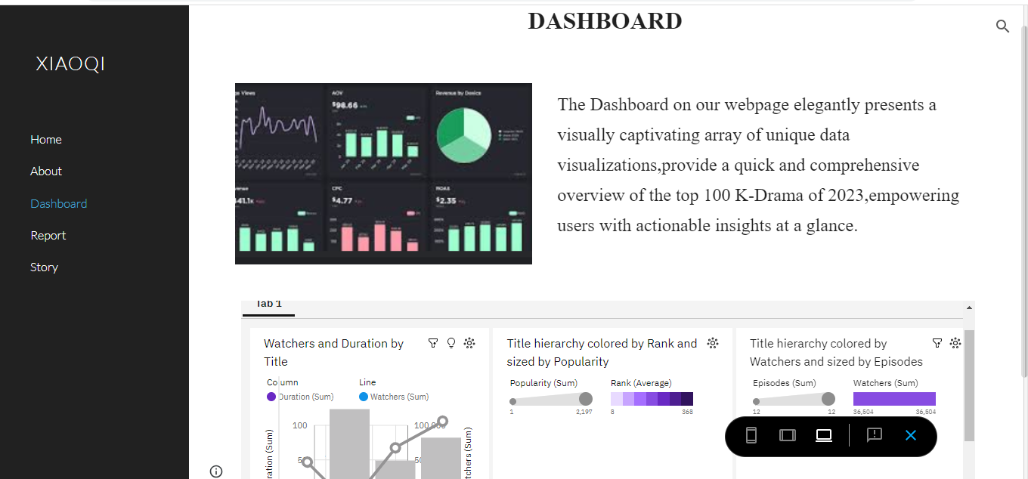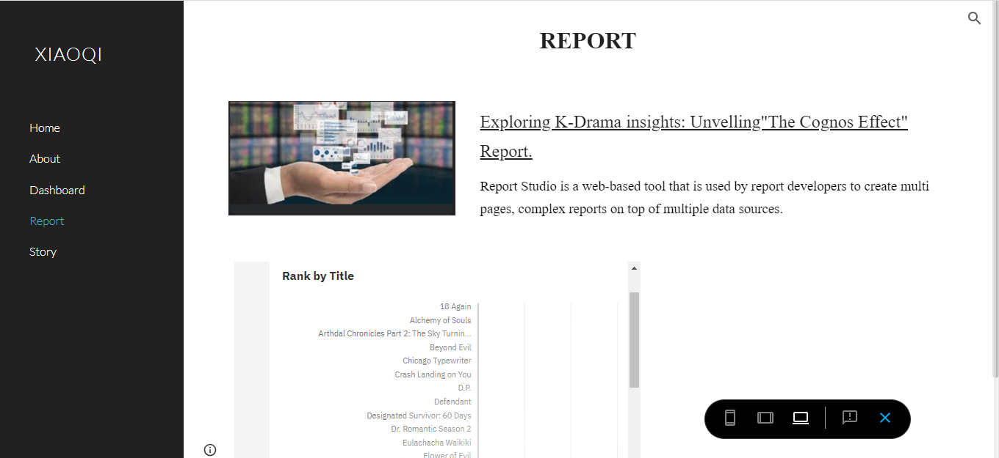

ADVANTAGES :

By utilizing Cognos advanced analytics and reporting features, stakeholders in Korean Drama industry can gain actionable insights to guide their decision-making processes, improve content creation strategies, optimize monetization models, and enhance audience engagement and satisfaction.

# APPLICATIONS:

The Analytics performed on the Top 100 Korean Drama 2023 dataset can provide insights into viewer preferences, enabling production companies to create content that resonates with diverse audiences. By understanding viewers interests and cultural inﬂuences , Korean Dramas can foster social connections, promote cultural exchange, and contribute to a shared viewing experience.

# CONCLUSION:

The Objective here is to leverage the capabilities of the Cognos A nalytics platform together, integrate , and analyse data on the top 100 Korean Dramas of 2023. By utilizing Cognos advance analytics and reporting features, stakeholders in Korean Drama industry can gain actionable insights to guide their decision- making processes, improve content creation strategies,optimize,monetization models, and enhance audience engagement and satisfaction.

# APPENDIX:

SOURCE CODE

<html>

<head>

<title>Analysis</title>

</head>

<body>

<iframe src="https://us1.ca.analytics.ibm.com/bi/?perspective=story&amp;pathRef=.my_folders%2Fstory%2Bboard&amp;closeWindowOnLastView=true&amp;ui_appbar=false&amp;ui_navbar=false&amp;shareMode=embedded&amp;action=view&amp;sceneId=-2&amp;sceneTime=0" width="1320" height="1200" frameborder="0" gesture="media" allow="encrypted-media" allowfullscreen=""></iframe>

<iframe src="https://us1.ca.analytics.ibm.com/bi/?perspective=dashboard&amp;pathRef=.my_folders%2Fkdrama%2Bdashboard&amp;closeWindowOnLastView=true&amp;ui_appbar=false&amp;ui_navbar=false&amp;shareMode=embedded&amp;action=view&amp;mode=dashboard&amp;subView=model0000018a26ee89a8_00000006" width="1320" height="1200" frameborder="0" gesture="media" allow="encrypted-media" allowfullscreen=""></iframe>

<iframe src="https://us1.ca.analytics.ibm.com/bi/?perspective=explore&amp;pathRef=.my_folders%2FNew%2Bexploration%2Bkd&amp;closeWindowOnLastView=true&amp;ui_appbar=false&amp;ui_navbar=false&amp;shareMode=embedded&amp;subView=model0000018a2b28b41d_00000003" width="1320" height="1200" frameborder="0" gesture="media" allow="encrypted-media" allowfullscreen=""></iframe>

</body>

</html>